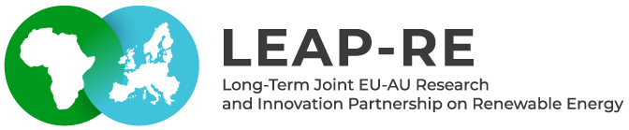

Strategy for Renewable Energy   
research-capacity in Africa

**Deliverable 5.8: Report on the analysis about R&I capacities in Africa**

**31.12.2021**

[**www.leap-re.eu**](http://www.leap-re.eu/)

***Authors:***

* Mokhtar SELLAMI (MESRS, Algeria)
* Utku DEMIR (ZSI, Austria)

***Abstract***: This study mainly focuses on renewable energy (RE) related research in African countries between 2011-2020. The study has been carried out under the project [LEAP-RE](https://www.leap-re.eu/) (Long-Term Joint European Union - African Union Research and Innovation Partnership on Renewable Energy) Task 5.3: Strategy for RE research-capacity in Africa with the co-lead of [MESRS (Ministry of Higher Education and Scientific Research, Algeria)](https://www.mesrs.dz/) and [ZSI (Centre for Social Innovation, Austria)](https://www.zsi.at/).

* Disclaimer

The content of this report reflects only the author’s view. The European Commission is not responsible for any use that may be made of the information it contains.

Document information

|  |  |
| --- | --- |
| **Grant Agreement** | 963530 |
| **Project Title** | Long-Term Joint EU-AU Research and Innovation Partnership on Renewable Energy |
| **Project Acronym** | LEAP-RE |
| **Project Coordinator** | Vincent Chauvet ([Vincent.chauvet@lgi-consulting.com](mailto:Vincent.chauvet@lgi-consulting.com)) – LGI |
| **Project Duration** | 1st October 2020 – 31st December 2025 (63 Months) |
| **Related Work Package** | Pillar III – WP5 – Task 5.3 |
| **Related Task(s)** | Task 5.3Strategy for Renewable Energy research- capacity in Africa |
| **Lead Organisations** | MESRS (Algeria) |
| **Contributing Partner(s)** | ZSI (Austria) |
| **Due Date** | 31.12.2021 |
| **Submission Date** | 31.12.2021 |
| **Dissemination level** | Public |

History

|  |  |  |  |  |
| --- | --- | --- | --- | --- |
| **Date** | **Version** | **Submitted by** | **Reviewed by** | **Comments** |
| 27.6.2021 | 1 | SELLAMI Mokhtar | DEMIR Utku | uploaded on due date 31/12/2021 |
| 30.6.2021 | 2 | DEMIR Utku | SELLAMI Mokhtar |  |

**Table of contents**

* Abstract
* Disclaimer
* Document information
* Table of Contents
* List of abbreviations

|  |  |  |
| --- | --- | --- |
| **.** | **Introduction** | 6 |
|  | **Section I – Data Source and keywords** | 8 |
| **I** | **Extracting and cleaning keywords** | 9 |
| I.1. | Analysing African strategic agendas in RE | 9 |
| I.1.1 | Agenda 2063, “Africa we want” | 9 |
| I.1.2 | Science, Technology and Innovation Strategy for Africa (STISA-2024) | 9 |
| I.1.3 | Agenda 2030 for Sustainable Development | 9 |
| **I.2** | **Extracting keywords** | 10 |
| I.2.1 | Identification of keywords from SDGs: | 10 |
| I.2.2 | Extracting keywords from the LEAP-RE multiannual roadmaps | 11 |
| I.2.3 | Benchmarking EU-Africa research projects in FP6-FP7 and H2020: | 12 |
| I.2.4 | Geographical Keywords associated to African and European countries: | 12 |
|  | **Section II – Methodology and Results** | 14 |
| **1** | **Terminology** | 14 |
| **2** | **General overview on yearly outputs for European countries** | 15 |
| **3** | **Analysing African publications** | 17 |
| **3.1** | Overall Figures | 17 |
| **3.2** | **Regional Analysis** | 20 |
| 3.2.1 | Northern Africa | 21 |
| 3.2.1.1 | Egypt | 23 |
| 3.2.1.1.1 | Cairo University | 25 |
| 3.2.1.2 | Algeria | 27 |
| 3.2.1.2.1 | Renewable Energy Development Center (CDER) | 28 |
| 3.2.1.3 | Morocco | 29 |
| 3.2.1.3.1 | Mohammed V University | 31 |
| 3.2.2 | Western Africa, Central Africa, Eastern Africa | 32 |
| 3.2.2.1 | Western Africa | 33 |
| 3.2.2.2 | Central Africa | 35 |
| 3.2.2.3 | Eastern Africa | 37 |
| 3.2.2.4 | Selected Institutions and Institutional Co-publication Network | 39 |
| 3.2.2.4.1 | Covenant University (Nigeria) | 40 |
| 3.2.2.4.2 | University of Nigeria | 42 |
| 3.2.2.4.3 | Université de Yaoundé I (Cameroon) | 43 |
| 3.2.2.4.4 | Addis Ababa University (Ethiopia) | 45 |
| 3.2.2.4.5 | Mekelle University (Ethiopia) | 46 |
| 3.2.3 | Southern Africa | 47 |
| 3.2.3.1 | South Africa | 49 |
| 3.2.3.1.1 | University of KwaZulu-Natal | 50 |
| 3.2.3.1.2 | University of Cape Town | 52 |
| 3.2.3.1.3 | Stellenbosch University | 53 |
| **3.3** | **Domain Analysis** | 55 |
| 3.3.1 | Physical Sciences | 55 |
| 3.3.2 | Technology | 59 |
| 3.3.3 | Life Sciences & Biomedicine | 62 |
| 3.3.4 | Social Sciences and Arts & Humanities | 65 |
| **4** | **Conclusion** | 68 |
| **5** | **References** | 72 |

**List of abbreviation**

AREI Africa Renewable Energy Initiative,

AOSTI African Observatory of Science, Technology, and Innovation

AU African Union

UN United Nations

AUC African Union Commission

CSP Concentrated Solar Power

ECOWAS Economic Community of West African States

EU European Union

GII Global Innovation Index

HLPD High Level Policy Dialogue

IP Intellectual Property

JAES Joint Africa–EU Strategy

LEAP-RE Long European African Partnership in Renewable Energy

M&E Monitoring and Evaluation

MENA Middle East and North Africa

NEPAD New Partnership for Africa’s Development

NIS National Innovation System

OECD Organization for Economic Co-operation and Development

R&D Research and Development

RE Renewable Energy

RECs Regional Economic Communities

SDGs Sustainable Development Goals

S&T Science and Technology

SOM Senior Official Meeting

STEM Science, Technology, Engineering, and Mathematics

STI Science, Technology, and Innovation

STISA-2024 Science, Technology, and Innovation Strategy for Africa 2024

UN United Nations

UNESCO United Nations Educational, Scientific and Cultural Organisation

UNSD United Nations Statistics Department

WIPO World Intellectual Property Organization

WoS Web of Science

**Introduction:**

STI is a key enabler to achieve the goals of the African Union (AU) Agenda 2063 and the UN Agenda 2030. It requires specific instruments for socioeconomic growth including publication of scientific papers.

In this deliverable we focus on high ranked publications analysis in renewable energy in Africa. The use of scientometric techniques will help government, institutions, private sector, civil society and communities not only to measure the scientific and technological progress through quantitative analysis and its productivity, but to identify institutions which could serve as pillar to develop long term fruitful forefront cooperation.

In order to deliver a comprehensive overview of national capacities and co-publication networks we shall use data from Clarivate’s Web of Science (WoS) databases [1]. The methodology to select keywords and to extract data are explained later. This mapping covers the identification of scientific networks and publications, as well as universities, faculties, research teams and their interconnexion. First results demonstrate that the number of scientific publications produced by Africans has risen significantly over the period 2011-2020, even it accounts for a tiny portion over the world. Compared to Europe, the regional, continental and intercontinental mapping generated using visualizing software [2], reinforce the urgent need to develop International partnerships and cooperation mainly in the framework of the existing programme LEAP-RE.

The final target is to support new (or existing) mechanisms which may involve networking by matching researchers from both continents to create communities in RE, teaming (for creating centres of excellence), twinning (institutional co supervision, post-doctoral programmes), and sharing infrastructures. The framework of such vision was declined in the new Africa-Europe Alliance for Sustainable Investment and Jobs, Horizon Europe and the new Research Framework Programme for the period 2021-2027 that open up new opportunities in the join AU-EU strategy (5th SOM, AU-EU HLPD on STI).

The organization of the Deliverable 5.3 “Strategy for RE research-capacity in Africa” is structured as follows. Section one is dedicated to the identification of appropriate key-words to build the query to select publications on RE, using the Web Of Science. These keywords are extracted from main documents, African strategies STISA-2024, Africa 2063, Agenda 2030 and the different Multi-Annual Roadmap developed in PRE-LEAP-RE. In section two the methodology will be explained and first results will be displayed using visualization software. In Section three we shall provide national and regional analysis of teams and networks regarding the different areas of research. In section four we discuss the results and ranking of African institutions in different research domains. In conclusion we highlight the capacity dimensions and capacity gaps and provides a summary and policy recommendations.

The results, which will be displayed in the following chapters, are generated through a cleaned, normalised and recategorised dataset created with the data collected from the [Clarivate’s Web of Science](https://www.webofscience.com/) databases. A comprehensive discussion about the methods can be found in Section [2](../../../../../../../C:/Users/SELLAMI/Desktop/Deliv5.3/01_bookdown/_book/method.html).

Following the explanation of the methodology in Section2, the results of the study. Will be displayed. A general overview of the yearly RE-related publication output in the European continent, will be followed by the most visible countries and organisations in Africa as well as the distribution of research domains and areas. The regional analysis generally deals with the most visible countries in each region as well as their co-publication networks which also include interregional (partnerships with other African countries from other regions) and intercontinental (partnerships with countries from other continents) collaborations. Furthermore, the analysis also focuses on selected countries in each region to display the most visible organisations and organisational co-publication networks as well. The regional analysis also includes at least 1 selected organisation from each selected country to present the most visible research areas and keyword/keyword pair networks on the organisational level. Finally, last section [3.3](../../../../../../../C:/Users/SELLAMI/Desktop/Deliv5.3/01_bookdown/_book/results.html) approaches the RE research in Africa from another direction and by splitting publications into research domains in order to discuss the most visible co-publication pairings between organisations as well as most visible keywords/ keyword pairs in each distinct cluster of scientific areas. In conclusion we’ll focus on the important next step of building the LEAP-RE research community (ies).

**Section I – Data Source and keywords**

**I – Extracting and cleaning keywords**

**I.1. Analysing African strategic agendas in RE [Africa2063, STISA, SDGs] and European programmes in the field of RE**

**I.1.1) Agenda 2063, “Africa we want”**

Agenda 2063 “Africa we want”[1] encapsulates Africa’s development and transformation priorities for the coming four decades. Central to Agenda 2063 is the sustainable transformation of the continent (human capacities, infrastructures, employment, well-being, good governance).

Agenda 2063 is 7 aspirations, 34 priority areas, 20 goals, 174 targets and 200 indicators. Agenda 2063 is divided into five 10-year implementation periods. The first 10-year implementation plan covers the period 2013-2023 (corresponding to STISA programmes). The different goals connected to RE are:

1. A high standard of living, quality of life and well-being for all citizens
2. Well educated citizens and skills revolution underpinned by science, technology and innovation
3. Healthy and well-nourished citizens
4. Transformed economies
5. Modern agriculture for increased productivity and production
6. Environmentally sustainable and climate resilient economies and communities
7. Engaged and empowered youth and children

*Agenda 2063 has targets for an increase of 50% in electricity generation, 50% distribution and 70% of Africans having access to electricity by 2023.*

**I.1.2) Science, Technology and Innovation Strategy for Africa (STISA-2024)**

The STISA-2024 [2] has been developed when the African Union was formulating the long-term AU Agenda 2063. The STISA-2024 is the first of the ten-year incremental phasing strategies to respond to the demand for science, technology and innovation to impact six critical sectors:

1. Eradicate Hunger and ensure Food and Nutrition Security: Agriculture/Agronomy in terms of cultivation technique, seeds, soil and climate- Industrial chain in terms of conservation and/or transformation and distribution infrastructure and techniques
2. Communication (Physical & Intellectual Mobility): Physical communication in terms of land, air, river and maritime routes equipment and infrastructure and energy- Promoting local materials- Intellectual communications in terms of ICT
3. Protect our Space: Environmental Protection including climate change studies- Biodiversity and Atmospheric Physics- Space technologies, maritime and sub-maritime exploration- Knowledge of the water cycle and river systems as well as river basin management

**I.1.3) Agenda 2030 - UN Sustainable Development Goals**

The 2030 Agenda [3] is a plan of action for sustainable development goals representing also Africa’s priorities for the post-2015 development agenda. SDGs are 17 Goals, with targets and indicators.

-SDG1: End poverty in all its forms everywhere in the world

-SDG2: End hunger, achieve food security and improved nutrition and promote sustainable agriculture

-SDG3: Ensure healthy lives and promote well-being for all at all ages

-SDG4: Ensure inclusive and equitable quality education and promote lifelong learning opportunities for all

-SDG5: Achieve gender equality and empower all women and girls

-SDG6: Ensure access to water and sanitation for all

-SDG7: Ensure access to affordable, reliable, sustainable and modern energy

-SDG8: Promote sustained, inclusive and sustainable economic growth, full and productive employment and decent work for all

-SDG13: Take urgent action to combat climate and its impacts

-SDG15: Protect, restore and promote sustainable use of terrestrial ecosystems, sustainably manage forests, combat desertification, and halt and reverse land degradation and halt biodiversity loss.

For each Agenda2030 SDGs AND/OR Africa2063 targets an excel file in [Annexe1, page(73) ] is constructed. It includes the following information’s:

1. Targets linked to renewable energy and its relevance [strong, high, weak]
2. Associated keywords or string
3. Which RE technologies could solve

**I.2) – Extracting keywords**

**I.2.1) Identification of keywords from SDGs:**

|  |  |  |
| --- | --- | --- |
| **#** | **SDGs** | **Keywords** |
| **1** | **SDG1:** End poverty in all its forms everywhere | Energy, Microgrids, climate change, mitigation, # vulnerability to climate  # Access to Basic Goods and Services, # Financial Inclusion |
| **2** | **SDG 7** Ensure access to affordable, reliable, sustainable and modern energy for all. | # Access to (clean) Energy, # Transition from Fossil to Clean Energy  # Energy Efficiency, #1. Solar Photovoltaic Energy, #2. Wind Energy, #3. Energy Efficiency in the Building, #4. Solar Thermal Energy, #5. Marine energy,  #6. Storage of Energy, #7. Geothermal Energy, #8. Bioenergy,  # 9. Hydrogen and Fuel Cells, #10. Hydroelectricity, consumers energy, solar systems, solar panels, nuclear, alliant energy, solar, electricity companies, direct energy, wind turbine, stream energy, distributed generation, solar generators, natural gas, nuclear power plant, sun power, green mountain energy, solar power  #11. Materials : (industrialization of certain components of renewable energy systems such as solar panels or wind turbine blades)]. |
| **3** | **SDG13** Take urgent action to combat climate change and its impacts. | # Climate Adaptation strategies  # CO2 harvesting and storage  # Greenhouse Gas Reduction |

**I.2.2) Extracting keywords from the LEAP-RE multiannual roadmaps [3]**:   
Within Pillar 2, eight projects broadly address the MARs (1, 3, 4, 5, 6), Pillar 1 with thirteen projects selected is still addressing the different pathways in RE. .

|  |  |  |
| --- | --- | --- |
| **#** | **Multiannual Roadmaps (MARs)** | **Keywords** |
| **1** | Mapping joint research and innovation actions for future RES development | energy access, energy transition, low carbon energy sources, energy infrastructure, energy access, energy uses, renewable energy systems (RES), off grid, decarbonization, thermal energy, demonstration systems, stand-alone systems, green electrification , geothermal resources, African electricity production, power plants, geothermal resources, geological data, geothermal energy systems, geothermal systems, climate resilience, rural electrification, green-field mini-grid, energy mix scenario, alternative energy sources, photovoltaic systems, flexible solar panels, solar powered generator, off grid, solar outdoor lighting, wind generator, solar panel installation, solar farm, best solar panels, pv panels, sustainable energy, , renewable energy resources, renewable sources of energy, solar tracker |
| **2** | End-of-life and second-life management and environmental impact of RE components - | solar panels, solar PV panels, photovoltaic panel waste, electric vehicles, storage systems, wind turbine blades, second life components, lead‐acid batteries, Li‐ion batteries, clean energy, off‐grid solar, quality of life, e‐waste stream, off‐grid solar, storage products |
| **3** | Smart stand-alone systems (SAS) - | Smart stand‐alone systems, energy mix, off‐grid, clean cooking, lighting water pumping, small microgrid, mini grid stability, production of electricity, grid infrastructures, small-scale, off-grid systems, wind power, sunpower, solar panel cost, hydropower, panel solar, solar battery, renewable energy sources, biomass energy, solar cooker, energy efficiency, solar panels for home, alternative energy, sources of energy, solar panels for sale, photovoltaic cells, hydroelectric energy, solar generator, solar inverter, solar roof, energy resources, clean energy, outdoor solar lights, solar panel kits, solar shingles |
| **4** | Smart grid (different scale) for off grid application - | Smart grid, off grid, access to electricity, penetration of Res, decentralized electrification, coupling different RES, mitigating energy poverty, Hybrid and Smart RES Grids, storage systems. |
| **5** | Processes and appliances for productive uses (PRODUSE) – | off‐farm employment, value chain segments, cold chain technologies, food processing, Clean cooking, cogeneration, , solar electricity production, solar system, solar panels, csp, wind turbine, solar city, solar battery charger, wind energy, renewable resources, green energy, photovoltaic, |
| **6** | Innovative solutions for priority domestic uses (clean cooking and cold chain) | clean cooking, firewood, charcoal, deforestation, land degradation; black carbon emissions; Indoor cooking, food waste, cookstoves, e-cooking, solar perovskites, Cooker design, storage of cold, power boosting, solar cooking, standalone solar cooker, silicon solar cells, solar water heater, energy conservation, |

To identify how LEAP-RE projects could be connected to AU-EU R&I needs, we’ll first use a matching process and comparison between the objectives of the six multi-annual roadmaps, thanks to the associated keywords, the technical keywords identified in the matrix of step [1] and the selected programs in Pillar2.

|  |  |  |  |
| --- | --- | --- | --- |
| **Multiannual roadmaps** | **PillarII projects** | **Keywords** | **Connexion to matrix (step1)** |
| ***Example with Multiannual roadmap 6….*** | | | |
| 6: Innovative solutions for priority **domestic uses** (clean cooking and cold chain) | WP10 PURAMS, solar cooking, standalone solar cooker, silicon solar cells, | clean cooking; energy poverty; improved cooking stoves; Electric clean cooking, Improved cookstove, Solar cooker, Cold chain, Supply chain, Cold chain logistics | saves health, time and money [SDG1], job opportunities [SDG8], Reducing smoke emissions, air pollution [SDG3], climate vulnerability [SDG11], girls kept out of school, etc… |

**I.2.3) Benchmarking EU-Africa research projects in FP6-FP7 and H2020:**

The benchmarking process is used to identify and analyze previous projects to determine their impact on the local or regional community, and to identify the human capacity as potential resource for R&I. The characteristic of the R&I partnership is to strive to integrate research and innovation activities that have an impact on citizens. Thus, it will be assisted by the valuable lessons learned from projects developed or underway in the field of sustainable energy; these are AU grant projects in renewable and sustainable energies, or EU projects. We can mention, but not limited to AREI (Africa Renewable Energy Initiative), CSP4Africa (Development of a cost-effective, modular and dry concentrating solar power for Africa), REELCOOP (REnewable ELectricity COOPeration), SOLPART(High temperature Solar-Heated Reactors for Industrials Production of Reactive Particulates), ECOWAS observatory for renewable energy and energy efficiency, EUROSUNMED  “Euro-Mediterranean Cooperation on Research & Training in Sun based Renewable Energies.. ”, etc. This overview of two binary digit research programs offers particularly to identify the gaps of research and cooperation activities, which is an issue of high priority to the EU-AU R&I Partnership in RE.

**I.2.4) Geographical Keywords associated to African and European countries:** For the identification of regions and countries, we adopted the United Nations geoscheme [4]. Europe with 27 countries and Africa with 55 countries divided into 5 regions North Africa, West Africa, East Africa, Central Africa and Southern Africa.

A total of approximatively 1000 keywords or composed keyword are identified. Data are cleaned, normalized and recategorized with the data collected from the [Clarivate’s Web of Science](https://www.webofscience.com/) databases [5]. An example of request to the system is giver in Annexe2 (page 77). These keywords are applied to all European countries (27) and then to African Countries (55).

Conclusion: In the previous section we invest mainly in collecting the keywords from different sources.

***Relaxing images***

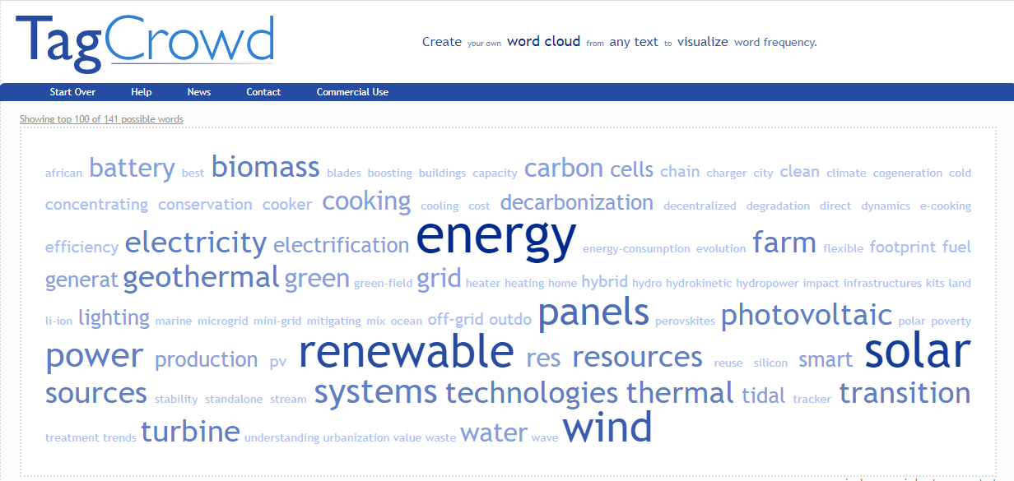

*Fig1: Tag Crowd: illustration of word frequency in selected keywords*

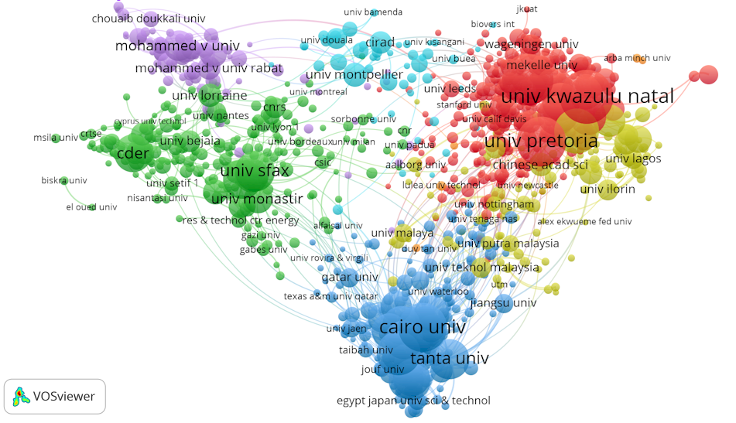

*Fig2: Anticipating on commenting African publications mapping, by displaying clusters in RE in South-Africa (in red), in Egypt (in blue), in Tunisia and Algeria (in green) and in Morocco (in purple), and their regional and international co-publications*

**Section II – Methodology and Results**

Following clarification of the motivation and methodology of the scientometric analysis on the renewable energy (RE) related research in Europe and Africa, this section is dedicated to the presentation of the different results.

After delivering a general overview on the most visible countries as well as distribution of scientific publications in European countries between 2011-2020, and the interaction between the two continent, we shall focus and deepen the analyses on African production in each of the 5 regions (Northern Africa, Western Africa, Central Africa, Eastern Africa, Southern Africa) individually.

Following clarification of the motivation and methodology of the scientometric analysis on the renewable energy (RE) related research in Europe and Africa, this section is dedicated to the presentation of the different results.

After delivering a general overview on the most visible countries as well as distribution of scientific publications in European countries between 2011-2020, and the interaction between the two continent, we shall focus and deepen the analyses on African production in each of the 5 regions (Northern Africa, Western Africa, Central Africa, Eastern Africa, Southern Africa) individually.

Analysis of the geographic regions include:

* Most visible countries.
* Regional, interregional, and intercontinental collaboration networks.
* Collaboration networks of the academic organizations in selected countries[4](../../../../../../../C:/Users/SELLAMI/Desktop/Deliv5.3/01_bookdown/_book/results.html).
* Analysis of the most visible research areas and the correlation network of the keyword/keyword pairs in the RE-related publications.

The analysis also focuses on selected countries in each region to display the most visible academic institution and organizational co-publication networks as well. The regional analysis also includes at least 1 selected organization from each selected country to present the most visible research areas and keyword/keyword pair networks on the organizational level.

At a second step The African publications will be analyzed under the 5 research domains Physical Sciences, Technology, Life Sciences & Biomedicine, Social Sciences and Arts & Humanities[6](../../../../../../../C:/Users/SELLAMI/Desktop/Deliv5.3/01_bookdown/_book/results.html). Analysis of each domain includes:

* Most visible inter-regional/ intercontinental collaborations
* Most visible and trending keywords/ keyword pairs.

## **1) Terminology**

## **Scientometry:** This new domain in expansion is the study of measuring and analyzing science, technology and innovation, it is a sub-field of bibliometrics

Research Area/ Research Domain. Research areas are the scientific fields defined by the Web of Science (WoS). Research domains are the 5 parent categories (Physical Sciences, Technology, Life Sciences & Biomedicine, Social Sciences, Arts & Humanities) of the research areas.[1]

Co-publication. A publication that has been produced with the collaboration of at least 2 authors from 2 different organizations.

Interregional co-publication. Interregionality in this Report refers to different African countries from different African Union (AU) regions. An interregional co-publication, therefore, is a paper published with the collaboration of at least 2 authors from African organisations from different regions of Africa.

Intercontinental co-publication. Co-publications of at least 2 organisations located on different continents.

Relative growth rate. A simple indicator of how many folds the number of publications has been increased in comparison with the number of publications in the start year (2011). The equation is simply:

rel_growth_rate:=end_value/start_value

**2) General overview on yearly outputs for European countries**

To give an idea on the potential of scientific cooperation and technological development with Europe, we introduce briefly some elements on research capacities in Europe. The number of papers published in journals indexed in the Web of Science for the European countries is 214,996, with many discrepancies between the top ranked Germany, Italy, Spain, France and Eastern countries. More than 50% of these papers are in Energy Fuels (26.16% ), Engineering Electrical Electronic (12.64%) and Environmental Sciences (12.45%).

The European Commission is the top funder, followed by Spanish Government and the German Research Foundation. The top three African co-publisher countries are Tunisia (1258 papers), Algeria (1226) and South Africa (1217).

We don’t focus on European publications, but it is relevant to illustrate the flux density of co-publications between Europe and Africa and vise-versa.

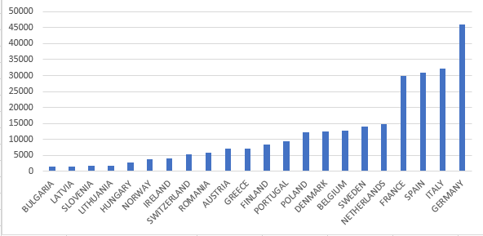

*Fig 3: European publications in RE – Germany is leading continental countries   
followed by Italy, Spain and France.*

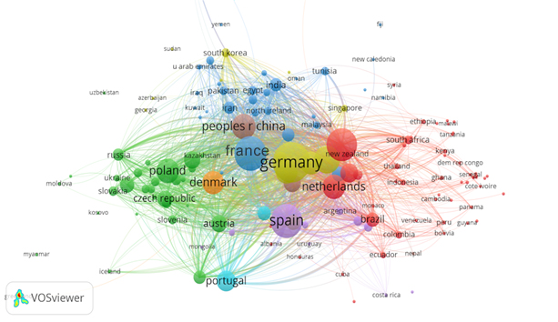

*Fig 4: map of European publications and related networks. This map is generated using  
 WoS records and the visualization software Vosviewer*

|  |  |
| --- | --- |
|  |  |
|  |

*Fig 5 – Overview of European and African publications and the partnership   
in co-publications*

The figure 5, shows clearly the predominance of European scientific production, first within Europe and then with the African Continent where South Africa and Egypt emerge. The more in-depth study of co-publications indicates that many European authors participate in publications domiciled in Africa. The reverse is also true. These clusters need to be strengthened and perpetuated.

## 3) Analysing African publications

## 3.1 Overall Figures

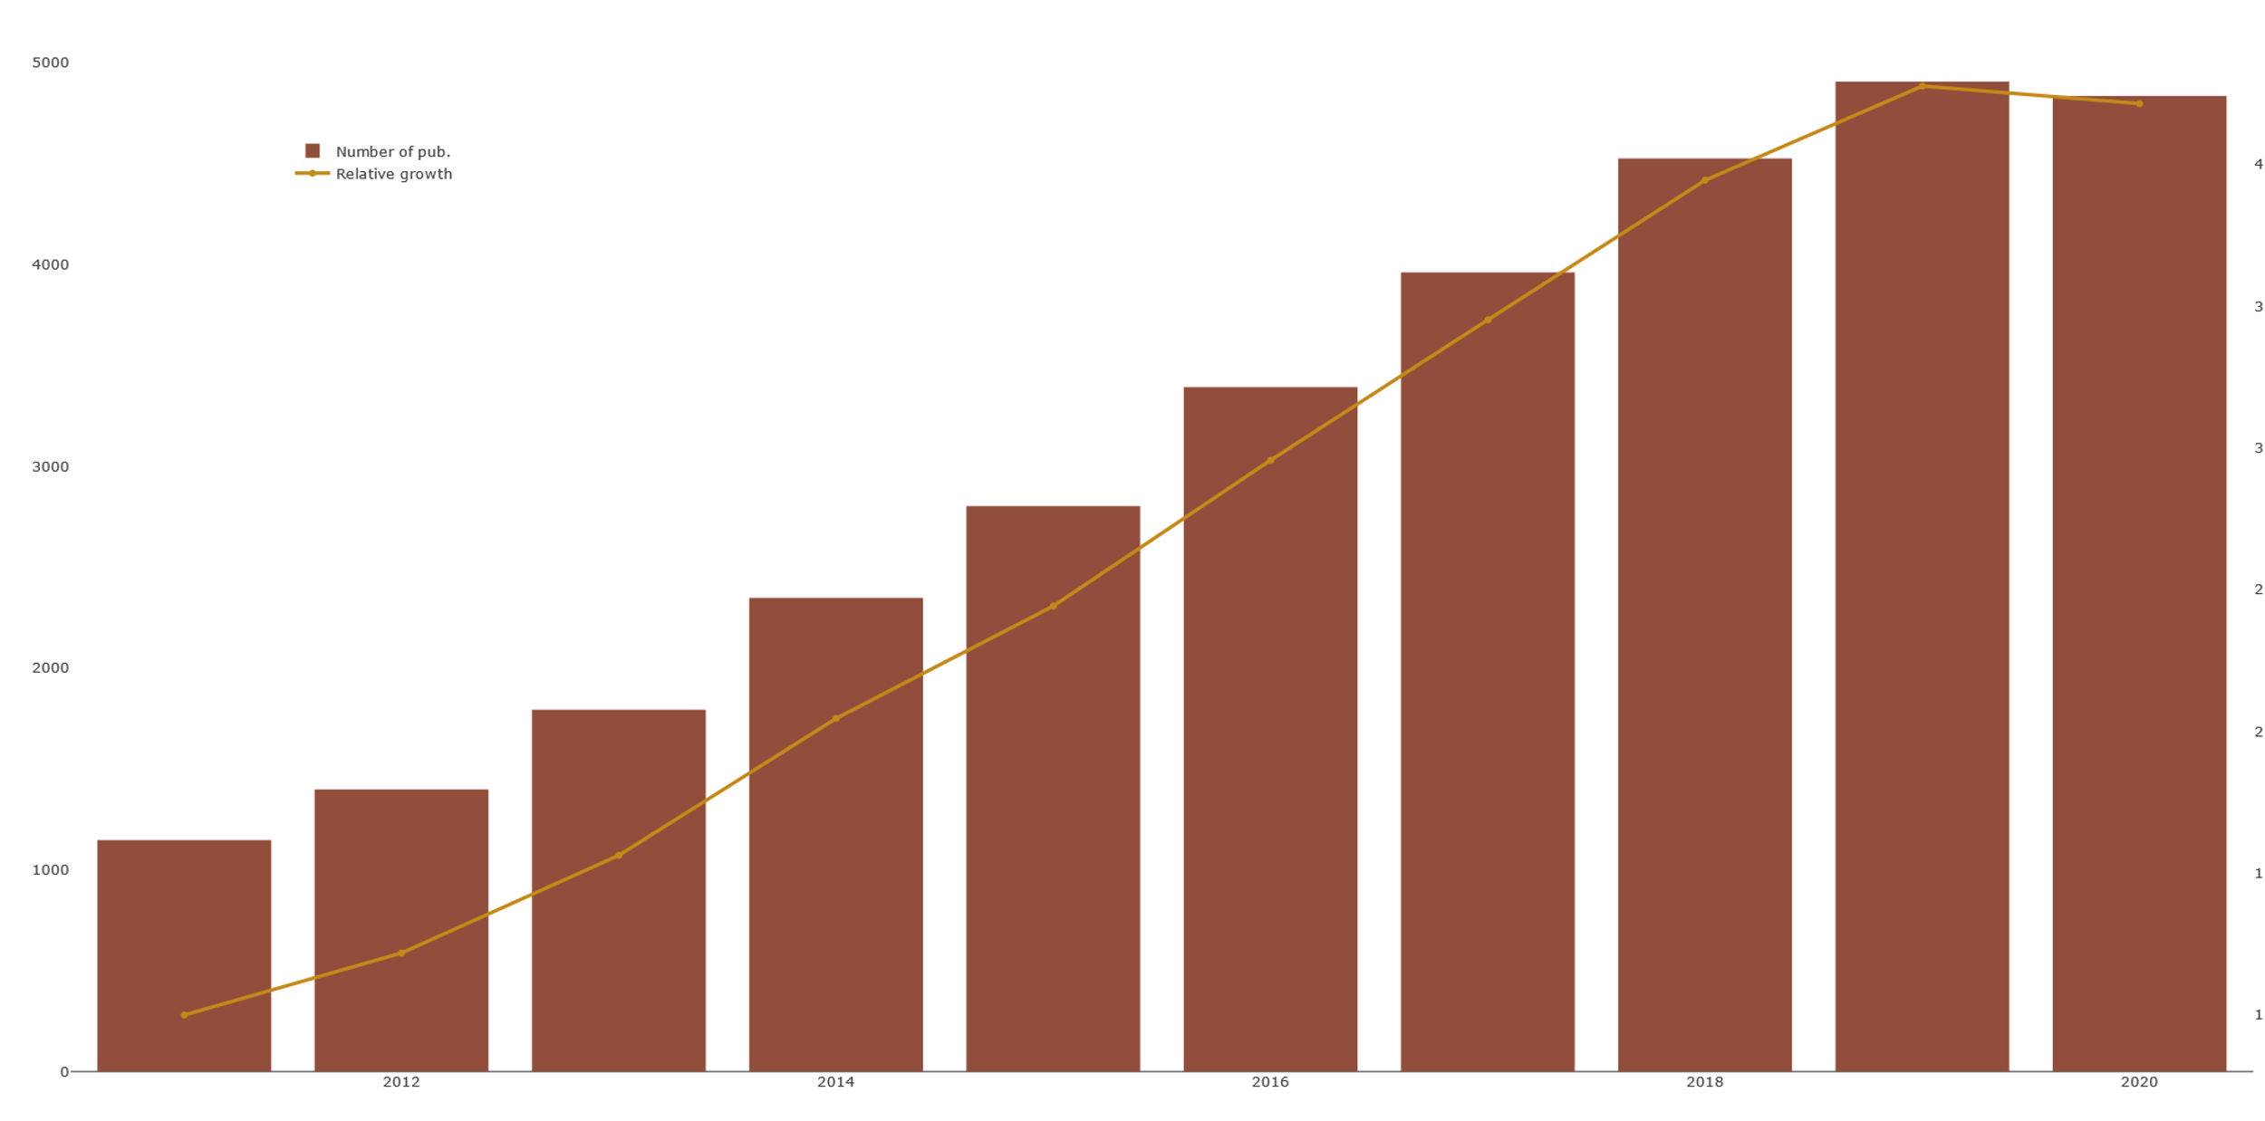

Figure 6: Number of RE-related publications in African countries over the   
years between 2011-2020

African countries have collaborated in approximately 31k renewable energy (RE) related publications in the 10 years range between 2011-2020. The number of those publications has been constantly increasing until 2019. Slightly declining publication numbers between 2019 and 2020 (see Figure [6](../../../../../../../C:/Users/SELLAMI/Desktop/Deliv5.3/01_bookdown/_book/results.html)) is likely caused by the latency in the database entries according to the explanation of Web of Science. Even after including the possibly incomplete amount of publications in 2020, the number of RE-related publications from the African countries in total increases from ~1.1k in 2011 to ~4.8k in 2020 which is an increment by factor ~4.2.

As Figure 7 shows, South Africa and Egypt are the most visible countries with 6.8k and 6.6k RE-related publications respectively. 20 African countries stay under 40 RE-related publications in total between 2011-2020.

The most visible countries are distributed diversely on the continent, however, other than the Northern African countries and South Africa only Nigeria contributed to over 1000 RE-related publications (2252 pub.) between 2011-2020.

*Figure 7: Total number of RE-related publications in African countries between 2011-2020*

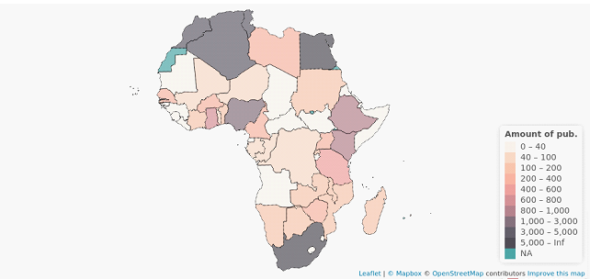

Although total publication output is a strong indicator of the most visible countries, it does not show the growth rate in the numbers. African countries that show a high increment rate in the number of publications despite having a relatively lower total amount of publications will be analysed in the following chapter.

Four of the most visible 5 organisations (University of Kwazulu-Natal, University of Cape Town, Stellenbosch University, and University of Pretoria) in RE-related publications are located in South Africa.

Each of them has close to or over 800 publications between 2011-2020, Cairo University from Egypt is following them with ~780 publications. Four other Egyptian institutions; namely Ain Shams University, Tanta University, National Research Centre of Egypt and Alexandria University are also among the 15 most visible organisations.

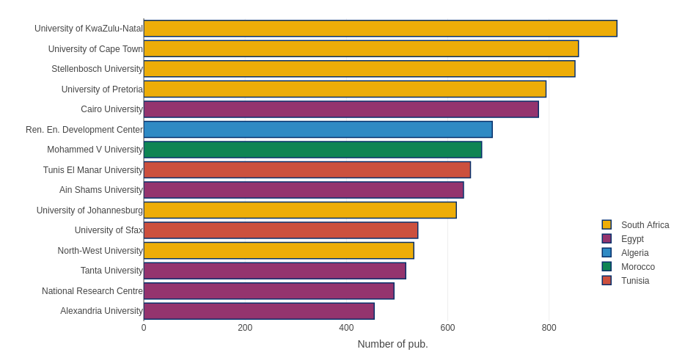Figure 8: Most visible 15 African institutions in RE-related publications 2011-2020

Tunis El Manar University and the University of Sfax from Tunisia are also in the most visible 15 organisations with ~650 and ~550 RE-related publications and Mohamed V University, the only organisation from Morocco in the list has ~670 RE-related publications.

Although most of the visible organisations are in general universities, the only organisation from Algeria in the most visible 15 organisations, namely Renewable Energy Development Center is an institution completely dedicated to RE-related research. The total number of RE-related publications of Renewable Energy Development Center is ~700 between 2011-2020.

Over 50% of the RE-related publications are associated with research areas from the Technology domain. Energy & Fuels is the most visible research area in total followed by Electrical & Electronic Engineering. Other Engineering fields like Chemical, Environmental, Mechanical Engineering are also among the visible research areas. Multidisciplinary discipline Green & Sustainable Science & Technology is the three most visible research area in total.

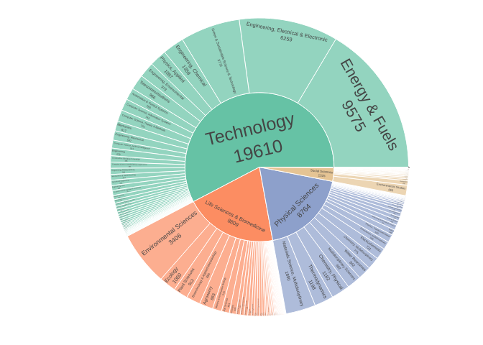Figure 9: Distribution of research domains in RE-related publications   
of African countries between 2011-2020

Life Science & Biomedicine and Physical Sciences have a similar number of publications (~8800 pub. both). Environmental Science and Ecology from Life Sciences & Biomedicine as well as Multidisciplinary Materials Science and Thermodynamics from Physical Sciences are also in the 10 most visible research areas.

Social Sciences (1325 pub.) is also not absent in the RE-related publications of African organisations. Environmental Studies is the most visible research area in this domain with 663 publications. The five research domain Arts & Humanities include only 45 publications, therefore, this domain will be analysed together with Social Sciences in Chapter [3.3](../../../../../../../C:/Users/SELLAMI/Desktop/Deliv5.3/01_bookdown/_book/results.html) Domain Analysis.

## 3.2 Regional Analysis

Following the overall figures of the RE-related publications in Africa, this section introduces the geographical regions of Africa to broaden the analysis further. Focusing on different regions of Africa prevents the over-representation of already relatively more visible countries in terms of publications and also enables a detailed analysis for individual countries and organisations.

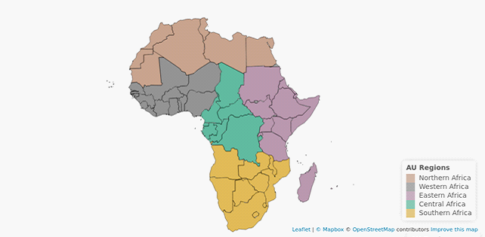  
Figure 10: African Union Geographic Regions

To determine the African regions, this study uses [African Union Geographical Regions](https://au.int/en/member_states/countryprofiles2) instead of the [United Nations Statistics Department](https://unstats.un.org/unsd/methodology/m49/) (UNSD). A presentation of the African Union regions can be seen in Figure 10.

As Figure 6 summarizes, four of the most visible African countries in the RE-related publications are from Northern Africa. South Africa has the highest number of RE-related publications (~6900) between 2011-2020, only other member country of Southern Africa in the most visible 15 countries is Zimbabwe with 230 RE-related publications between 2011-2020.

Nigeria, Ghana, Senegal from Western Africa; Ethiopia, Kenya, Tanzania, Uganda from Eastern Africa; and Cameroon, the only country from Central Africa, are among the 15 most visible countries following the most visible 5 countries.

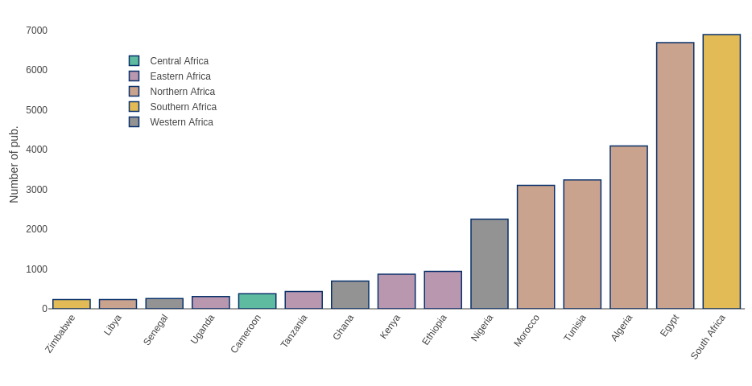Figure 11: The most visible 15 African countries in RE-related publications  
 between 2011-2020

### 3.2.1 Northern Africa

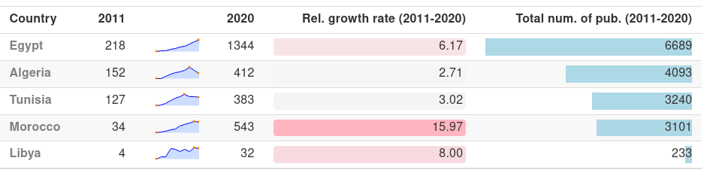Table 1: RE-related publication output in the most visible Northern African countries

Member countries of Northern Africa have collaborated approximately in half of the total number of all RE-related publications (17116 publications out of 31099) in Africa between 2011-2020. 4 of the 5 most visible African countries in RE-related publications are from the northern region; namely Egypt, Algeria, Tunisia and Morocco.

As Table 1 presents, all of the Northern Africa countries increased their number of RE-related publications until 2017. Although, as discussed in the previous chapter, slight declines in the number of publications between 2019-2020 are most likely caused by the delay of document entry into the Web of Science databases, Algeria and Tunisia show an earlier start of the decline in their number of publications starting in 2017 and 2018 respectively. In the case of Libya, however, volatility in the number of publications is expected as their total publication outputs are relatively lower.

Another important observation is in the relative growth rates[2], Morocco’s number of RE-related publications in 2020 are approximately 16 times higher than the number in 2011.

Another important observation is in the relative growth rates[3], Morocco’s number of RE-related publications in 2020 are approximately 16 times higher than the number in 2011. This growth rate is not only the highest in Northern Africa but in the whole continent among the most visible countries in RE-related research.

RE-related co-publications of the Northern African countries show a rich international network but the collaboration with other African regions seems to be relatively less dense. Only African countries from other regions which have co-published over 25 RE-related papers with Northern African countries are South Africa (28 pub.) and Nigeria (26 pub.).

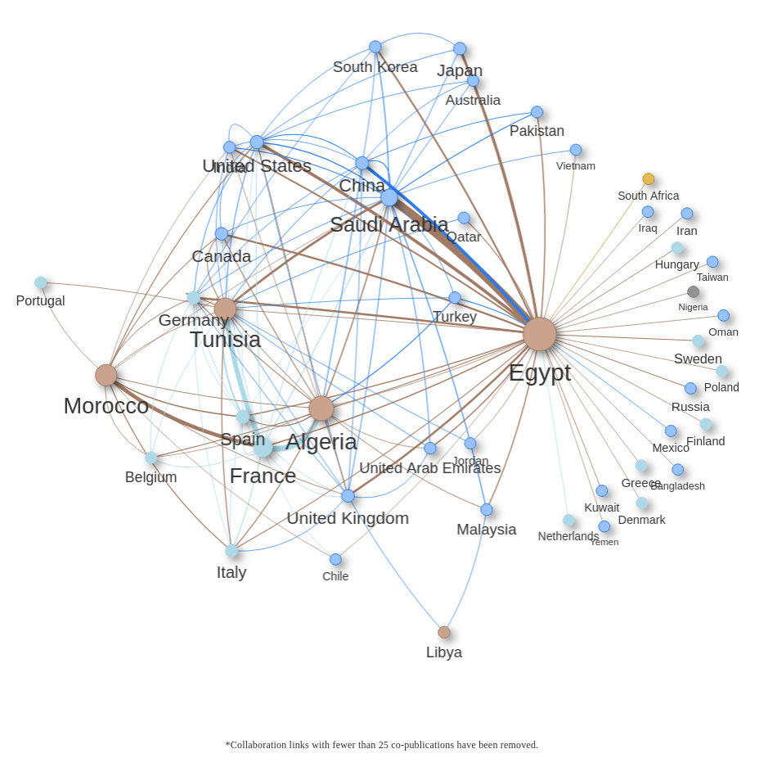

Egypt, the most visible country in Northern Africa in terms of RE-related publications, plays a central role in the network with ~6.6k publications in total. The relatively uniform distributed co-publication network of Egypt includes over 10 EU-27 countries as well as a number of countries from other regions of the world like the USA, China, India, United Kingdom. Egypt’s strongest link in the co-publications, however, is with organisations from Saudi Arabia.

Tunisia, Algeria and Morocco have relatively high numbers of collaborations with French organisations with 751, 881 and 601 co-publications respectively. France in general is the most visible EU-27 country in the RE-related co-publications with African countries. Out of France’s ~3250 RE-related co-publications with African countries ~2350 of those have been published with the collaboration of Northern African countries whereas Algeria and Tunisia being the most visible Northern African countries in those collaborations. The closest following EU-27 country in terms of RE-related co-publications is Spain (~580 out of ~820 co-publications with African countries) and Germany (~490 out of 1334 co-publications with African countries).

The 4 mentioned Northern African countries so far, Egypt, Algeria, Tunisia and Morocco are co-publication-wise relatively well interconnected, however, Libya stays out of the co-publication cluster in Northern Africa, from Libya’s 233 RE-related publications in the last 10 years none of the Northern African countries had over 25 co-publications with Libya. Instead, Libya’s most visible collaborators are United Kingdom (38 co-pub.) and Malaysia (29 co-pub.).

Following the given analysis of RE-related publication outputs in Northern Africa; Egypt, Algeria and Morocco have been chosen for the deeper analysis of the individual countries. While Egypt and Algeria hold the highest numbers of RE-related publications in the northern region, Morocco has been mainly chosen for the high growth rate in the number of publications.

#### 3.2.1.1 Egypt

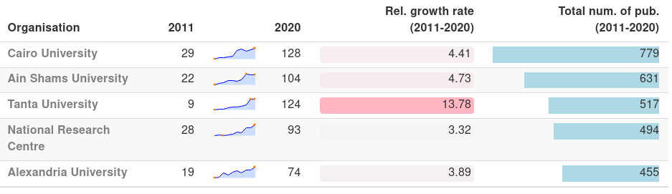Table 2: Re-related publication output of the most visible Egyptian organisations

The most visible Egyptian organisation in the RE-related publications is Cairo University with a total of 779 publications between 2011-2020. All of the most visible 5 organisations of Egypt display a fairly linear growth in the number of RE-related publications. However, Ain Shams University and Tanta University show a stagnation between 2019-2020 which might be caused by the delay of document entries into the Web of Science system as mentioned above. Furthermore, Tanta University, which had yearly fewer than 50 RE-related publications until 2016, published in 2019 and 2020 ~125 RE-related papers, this is a growth rate of ~14 fold with respect to the 9 publications in 2011.

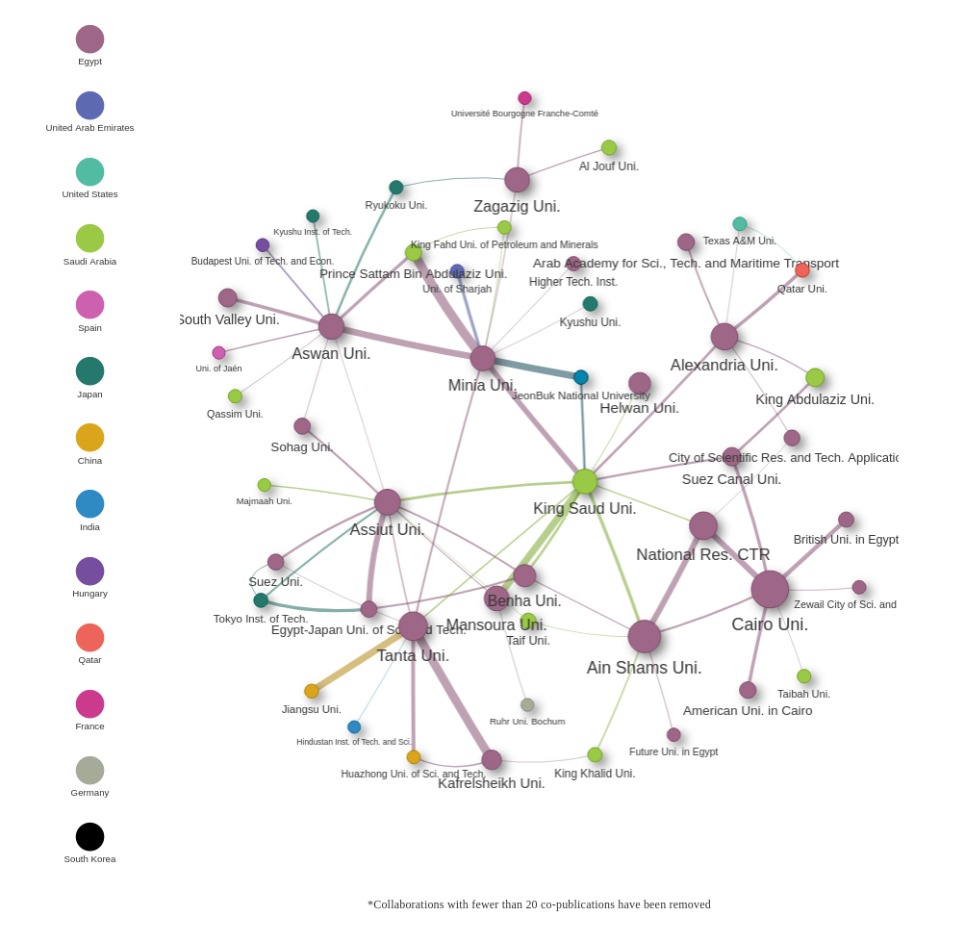Figure 12: Co-publication network in RE-related publications in organisations  
 from Egypt between 2011-2020

The Co-publication network of Egyptian organisations shows a relatively dense collaboration structure between Cairo University, Ain Shams University and National Research Centre of Egpyt. National Research Centre has over 50 co-publications with each of the other universities in that cluster. Cairo University is also in the centre of other 4 Egyptian organisations; namely Suez Canal Uni., British Uni. in Egypt, Zewail City of Sci. Tech and American Uni. in Cairo, with over 20 co-publications each.

Other visible collaboration links are between Minia and Aswan Universities with over 50 publications and between Tanta and Kafrelsheikh Universities with over 70 publications together. In general, collaborations with organisations from Saudi Arabia are highly visible in the network, especially King Saud University is a central node in the network with ~400 RE-related co-publications with Egyptian organisations.

Other than that, East Asian organisations also have a visible presence in the co-publication network of Egypt. Tanta University’s collaborations with Chinese Institutions Jiangsu Uni. and Huazhong Uni include 60 and 40 co-publications respectively. Several Japanese universities have collaborations with Aswan University, Zagazig University, Assiut University, Suez University, Egypt Japan University and Minia University with over 20 co-publications each. Minia University’s collaboration with South Korean institution JeonBuk National University also includes 60 RE-related co-publications between 2011-2020.

Visible organisations from EU-27 countries are Université Bourgogne Franche-Comté of France (over 25 co-publications with Zagazig University), Ruhr University Bochum from Germany (22 co-publications with Mansoura Uni.), Budapest University of Technology and Economics from Hungary and the University of Jaen from Spain (both over 25 co-pub. with Aswan University).

##### **3.2.1.1.1 Cairo University**

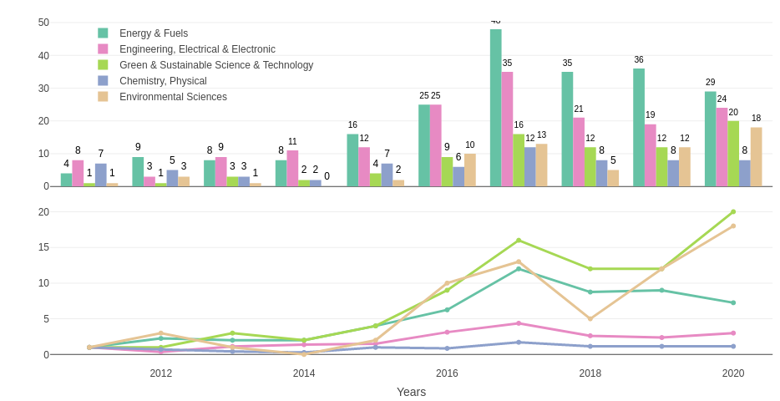Figure 13: Absolute and relative growth of the most visible research areas in RE-related publications of Cairo University between 2011-2020

Looking into the most visible research areas of Cairo University, out of 779 publications in total, the most visible research areas are aligning with the most visible research areas in RE-related publications from African countries in general.

Energy & Fuels, as well as Electrical & Electronic Engineering are the most visible research areas in Cairo university, however, the number of RE-related in those areas are not growing in the last years. After the spike in 2017 with ~50 publications, the number of publications from Energy & Fuels has fallen to ~30 publications in 2019 and 2020.

Green & Sustainable Science & Technology and Environmental Sciences on the other hand display relatively steady growth in numbers. Considering there was only 1 from each area in 2011, ~20 RE-related publications in 2020 makes those the fastest growing research areas in the RE-related publications of Cairo University.

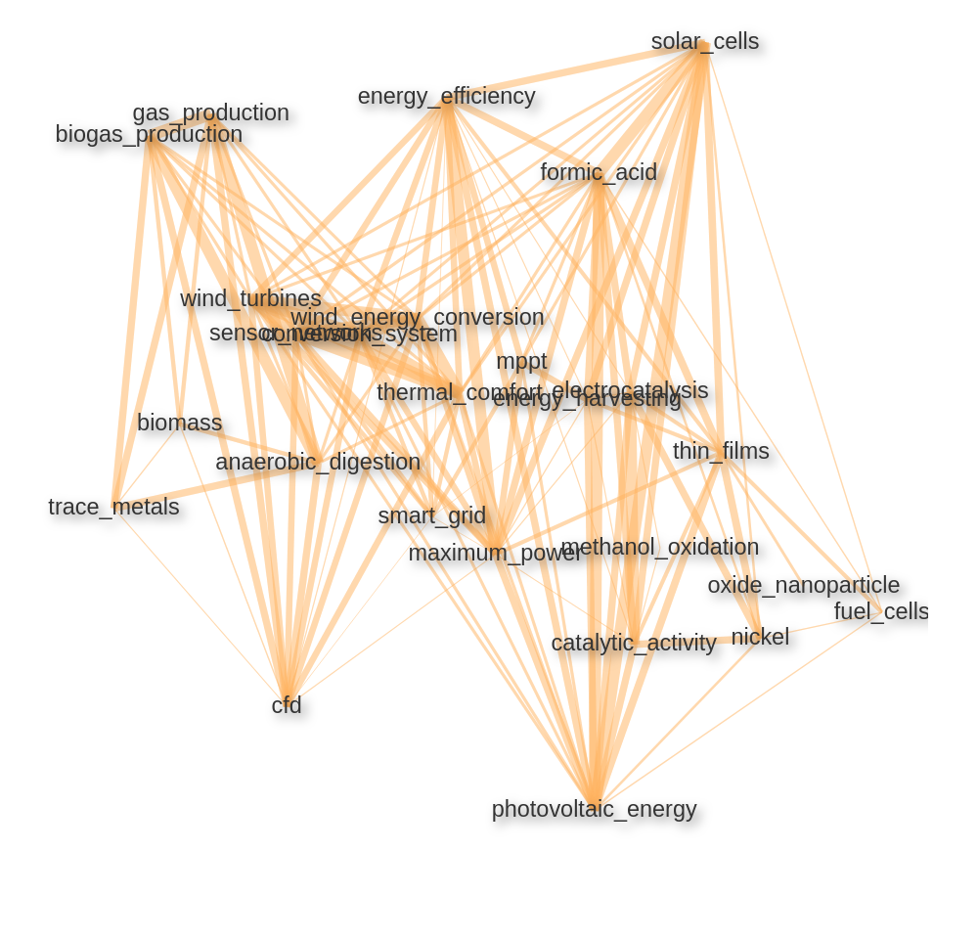Figure 14: Keyword/keyword pair correlation network in RE-related publications   
of Cairo University

Figure 14 displays the correlation network between the most common keywords and keyword pairs in the RE-related publications of Cairo University. As the clusters on the network graph indicate, there is a strong emphasis on solar energy, photovoltaic systems related keywords in Cairo University’s publications which is widely the case in African countries.

In relation, substances and technologies aiming to improve the efficiency of the effectiveness of solar cells like formic acid, MPPT (Maximum Power Point Tracking, an algorithmic DC-DC

converter that increases the efficiency of photovoltaic cells) are also among the visible keyword pairs. Other clusters include wind energy-related keywords as well as biogas/biomass related keywords. The approaches like electrocatalysis that aims to increase the output of solar and wind energy are also often mentioned in the RE-related publications of Cairo University.

#### 3.2.1.2 Algeria

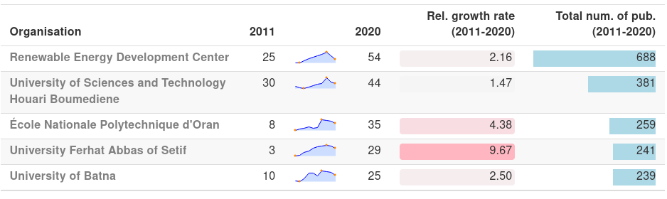Table 3: Re-related publication output of the most visible Algerian organisations

Renewable Energy Development Center, Algeria’s dedicated institution for RE-related research is the most visible Organisation in the country with ~690 publications. However, the number of RE-related publications of the institution is falling after a spike in 2018 with 127 publications. Although the latency in the record entry process in WoS databases might be causing a proportion of the decline, the number of publications in 2020 seems to be less than half of the number in 2018 (54 pub.).

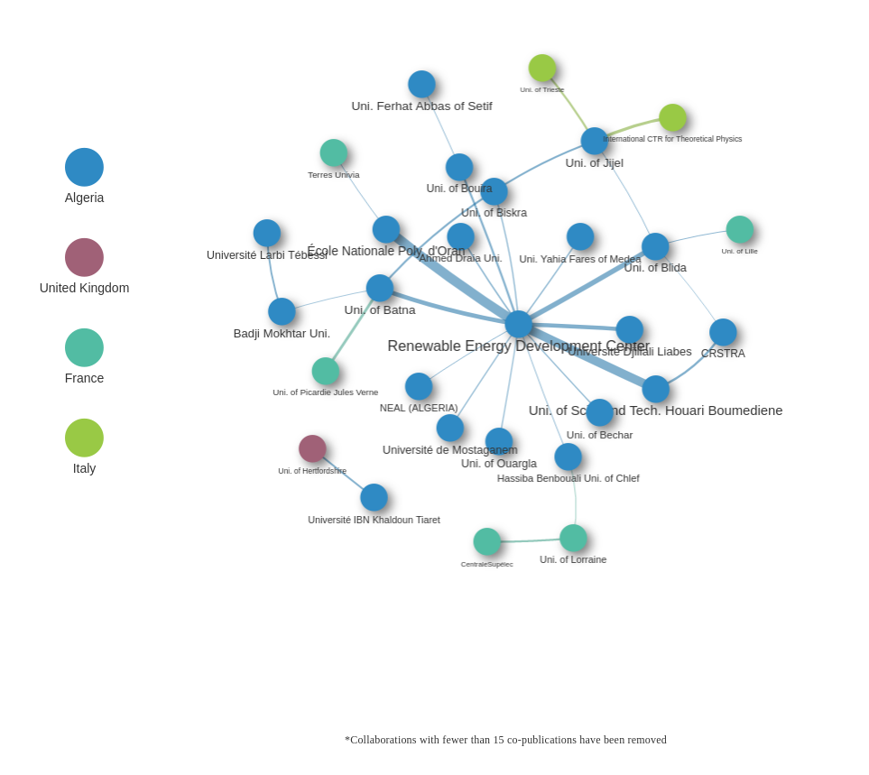Figure 15: Co-publication network in RE-related publications in organisations   
from Algeria between 2011-2020

Houari Boumediene University of Sciences is another Algerian institution that publishes RE-related papers consistently. A similar decline in the number of publications like in the case of Renewable Energy Development Center can be observed in the publications of Houari Boumediene University of Sciences after 2018 (from 75 publications to 44 publications in 2020). École Nationale Polytechnique d’Oran University, Ferhat Abbas of Setif and the University of Batna are other organisations with similar numbers of RE-related publications (259, 241, 239 pub. respectively), each of those has increased their yearly RE-related publication output to ~30. The decline in the number of publications after ~2018 can be observed in all of the most visible 5 organisations of Algeria.

Co-publication network of Algerian organisations mostly gathered around Renewable Energy Development Center, the to RE-related research dedicated institution collaborates with a number of other Algerian academic institutions, from which 14 of the collaboration links include close to or over 20 co-publications. The most visible collaborations with Renewable Energy Development Center are with Houari Boumediene University of Sciences and École Nationale Polytechnique d’Oran University, both with an output of over 60 co-publications.

Most of the international collaborators with more than 25 co-publications with Algerian institutions are French, the collaboration between University of Batna and University of Picardy Jules Verne is the most visible one with 27 co-publications between 2011-2020. University of Jijel collaborates often with Italian institutions like University of Trieste (23 co-pub.) and International Centre for Theoretical Physics (28 co-pub.). Other than that, University of Hertfordshire is the only organisation from the UK that has more than 20 RE-related co-publications with an Algerian organisation (University Ibn Khaldon) between 2011-2020.

##### **3.2.1.2.1 Renewable Energy Development Center**

The most visible research areas in the RE-related publications of Renewable Energy Development Center are Energy & Fuels and Green & Sustainable Science in Technology. All of the most visible 5 research areas are declining in numbers after 2018 which indicates that there was at least some effect caused by the delayed entry of the publications into the Web of Science databases. However, even after the possibly missing publication from the last years Thermodynamics seems to be becoming on of the consistently visible research areas in the RE-related publications of Renewable Energy Development Center.

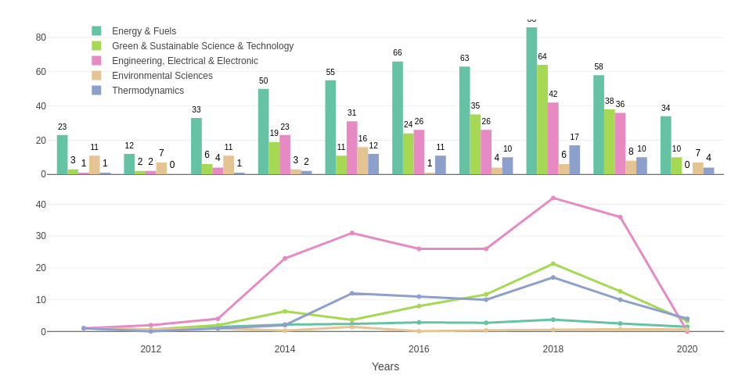Figure 12: Absolute and relative growth of the most visible research areas in RE-related publications of Renewable Energy Development Center between 2011-2020

Environmental Sciences which already included relatively high number of publications in 2011 (11 pub.) is also becoming a consistent area despite having volatile yearly number of publications between 2014-2017.

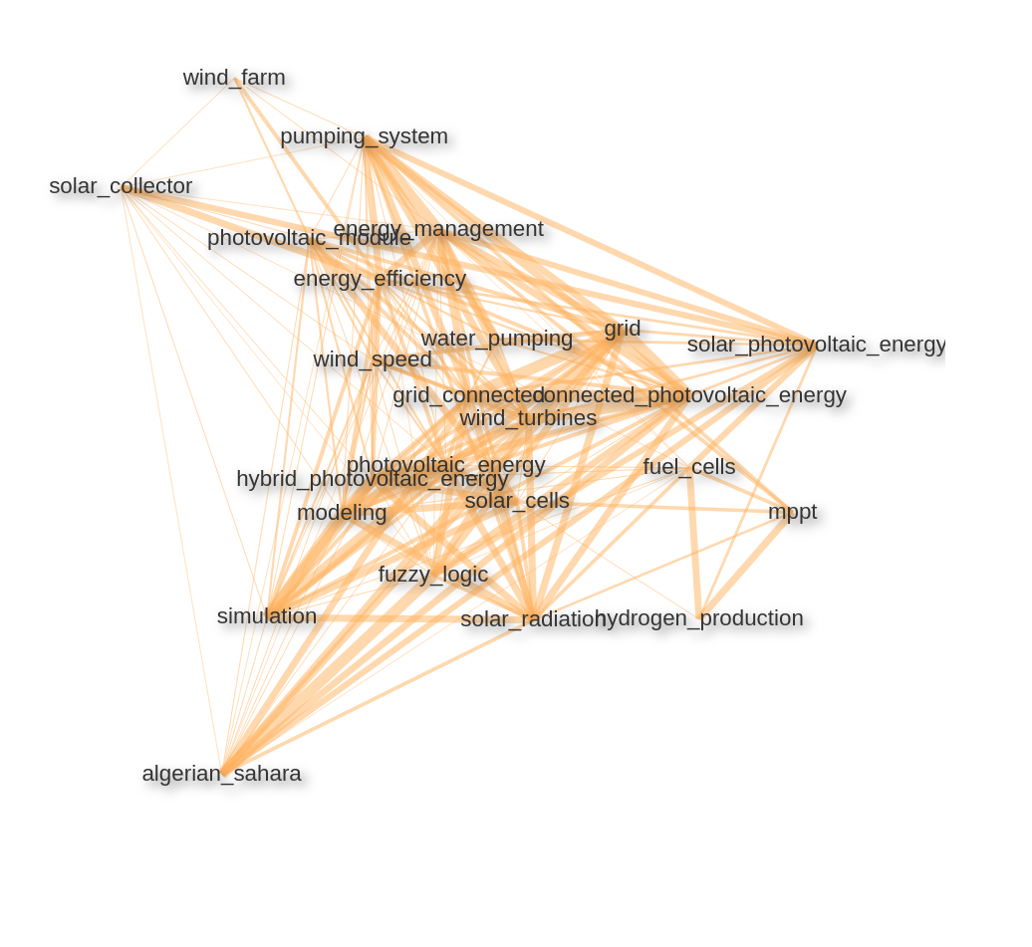Figure 13: Keyword/keyword pair correlation network in RE-related publications of Renewable Energy Development center

Keyword/keyword pair correlation network also displays heavily solar energy-related topics. We are seeing that the exploitation of Algerian Sahara for solar energy production is an often reoccurring theme in the publications of Renewable Energy and Development Center. Wind energy-related topics are also emphasized in the most visible keyword pairs.

The reason, why water pumping systems are relatively highly correlated with the solar energy keywords is the recent technological advances to build photovoltaic water pumps. Algeria is one of the most active countries in Africa that search for photovoltaic water pumping solutions especially for the isolated sites which are not connected to an electrical grid (see [Benghanem and Arab](../../../../../../../C:/Users/SELLAMI/Desktop/Deliv5.3/01_bookdown/_book/results.html) ([2007](../../../../../../../C:/Users/SELLAMI/Desktop/Deliv5.3/01_bookdown/_book/results.html)) for further reading).

#### 3.2.1.3 Morocco

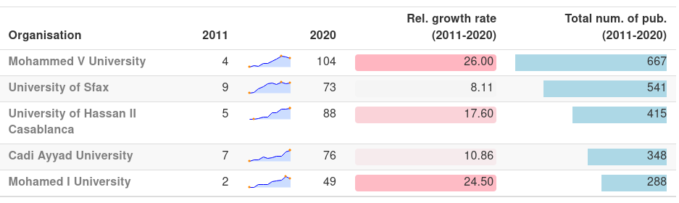Table 4: Re-related publication output of the most visible Moroccan organisations

Morocco has the most rapidly growing number of publications in the 15 most visible African countries in RE-related publications with having 543 publications in 2020 in comparison with 34 RE-related publications in 2011. The same pattern is also observable in the publications of Moroccan Institutions. Each one of the RE-wise most visible 5 organisations in Morocco had 1 digit RE-related publications in 2011 and each of those have published at least ~8 fold of those numbers in 2020.Mohamed V University is the most visible Moroccan institution in the RE-related publications with 667 publications in total between 2011-2020. There is a slight decline in the number of publications after 2018 but the university still collaborates in over 100 RE-related publications yearly. Mohamed V and Mohamed I Universities are both published in comparison with 2011 ~25 times more in RE-related papers. The University of Sfax, University of Casablanca and Cadi Ayyad University are most visible 2., 3. and 4. organisations respectively.

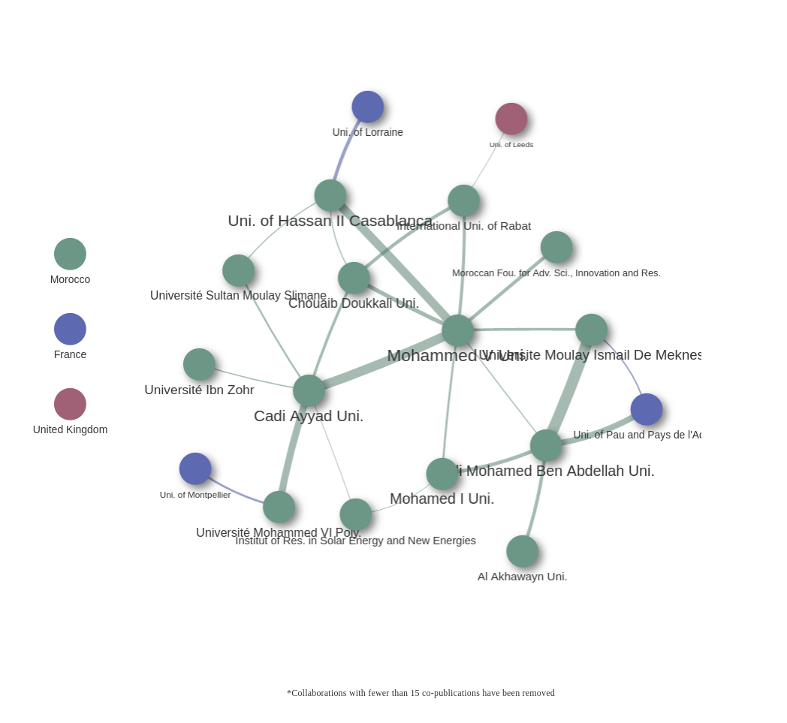

Moroccan organisations are well interconnected in RE-related publications. Although Mohamed V University stays in the centre of the network, institutions are evenly distributed. Especially the number of co-publications of Mohamed V Uni. with Cadi Ayyad Uni. and Uni. of Hassan II Casablanca (41 and 39 co-publications respectively) as well as the co-publications between Universite Moulay Ismail de Meknes and Sidi Mohamed Ben Abdellah Uni. (~50 co-publications) are most visible collaborations in Morocco.

Only a few intercontinental collaborations have an output of more than 15 co-publications with Moroccan organisations. Uni. of Lorraine, Uni. of Montpellier and University of Pau and Pays de l’Adour from France, Uni. of Leeds from the UK are the most visible intercontinental collaborators.

##### **3.2.1.3.1 Mohammed V University**

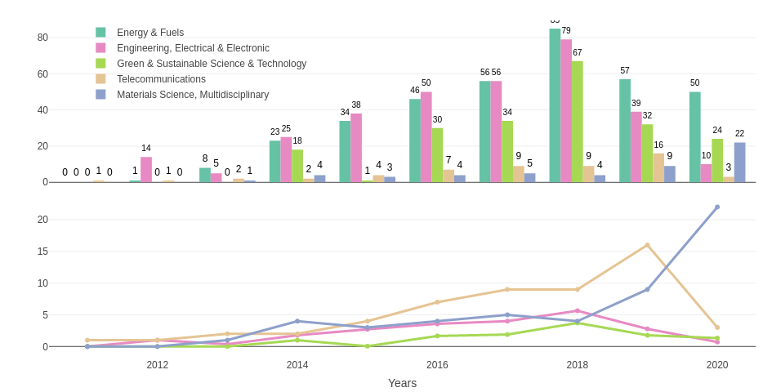

Similar to the other selected universities from the Northern Africa region Energy & Fuels has a strong presence also in the publications of Mohamed V Uni.. Considering, there was no recorded renewable energy-related publication from Mohamed V Uni. in 2011 and only 1 publication in 2012 in Web of Science databases, 2018 shows a strong contrast with 85 RE-related publications to the previous years. Electrical and Electronic Engineering is following Energy and Fuels closely in total RE-related publication from Mohamed V Univ.

Although, there are no recorded publications in Green and Sustainable Science & Tech. before 2014, it stays as the 3. most visible research area in the total numbers. In contrast to the other selected organisations so far one of the most visible research areas in the RE-related publications of Mohamed V University is Telecommunications and publications in Multidisciplinary Material Science are also increasing since 2015. Multidisciplinary Material Science is also the only research area that was increasing in numbers between 2019-2020 in the RE-related publications of Mohamed V University.

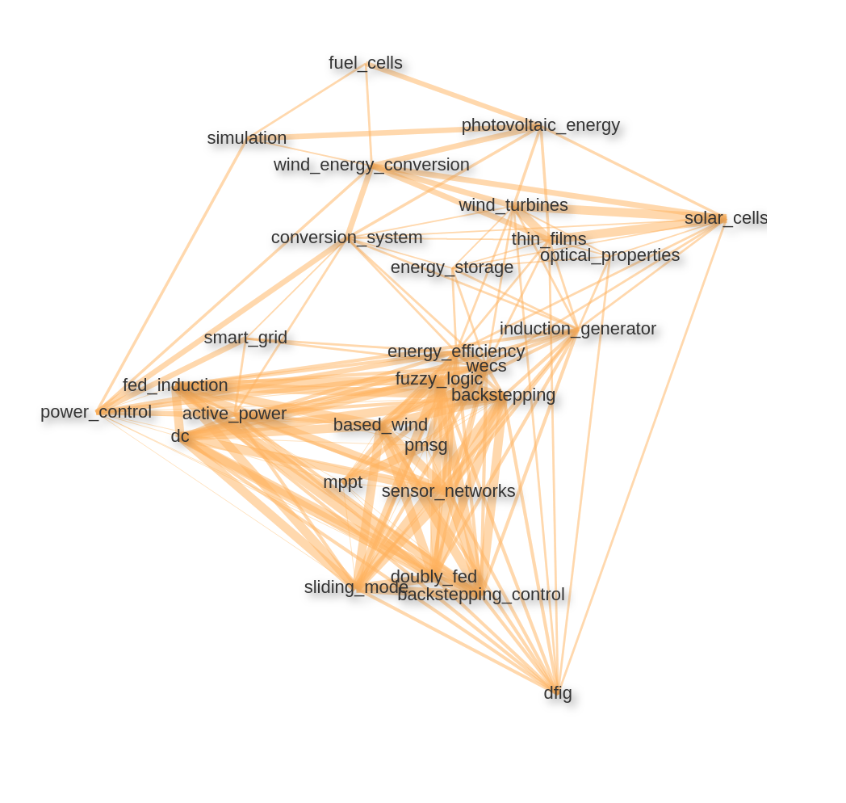Figure 16: Keyword/keyword pair correlation network in RE-related publications   
of Mohammed V University

The keyword/keyword pair correlation network of Mohamed V University also includes a number of solar energy and wind energy-related themes. Especially different types of conversion systems (wind energy conversion systems Mohamed V University. In relation, hybrid energy approaches like doubly fed induction generator (dfig) or backstepping control system that supports wind tribunes and photovoltaic systems (see [E. Ahmed and S. Yuvarajan](../../../../../../../C:/Users/SELLAMI/Desktop/Deliv5.3/01_bookdown/_book/results.html) ([2012](../../../../../../../C:/Users/SELLAMI/Desktop/Deliv5.3/01_bookdown/_book/results.html))) are emphasized. Also, dc-dc converter technologies like MPPT that aims to increase the efficiency of the photovoltaic systems are among the most visible keywords.

### 3.2.2 Western Africa, Central Africa, Eastern Africa

Western Africa, Central Africa and Eastern Africa are corresponding to a vast area of the African continent, however, on organisational level number of RE-related publications are relatively fewer in comparison. Therefore, although on country level those 3 regions will be analysed individually as in previous sub-chapters, on organisational level; firstly, table of most visible organisations will include organisations from selected 3 countries from each region and organisation network they will include all 3 regions on a single graph.

#### 3.2.2.1 Western Africa

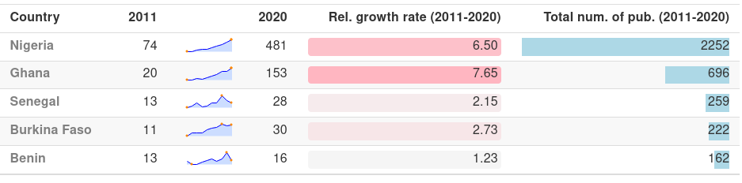Figure 17: RE-related publication output in Western African countries

Western African countries Nigeria and Ghana have been increasing their RE-related publication output in a consistent manner in the 10 years range (see table [3.21](../../../../../../../C:/Users/SELLAMI/Desktop/Deliv5.3/01_bookdown/_book/results.html)) without any stagnation. Although Nigeria’s number of publications in 2011 was already relatively high in comparison (74 pub.), the number of publications in 2020 was ~6.5 fold (481 pub.) of that. In a similar fashion, Ghana has increased its RE-related publication output from 20 in 2011 to 153 in 2020 which is an increment of a factor of ~7.5.

Senegal, the third most visible country in the region shows a volatile progression with a sharp decline in the number of RE-related publications after 2018 from 48 yearly publications to 28. Burkina Faso is following Senegal with relatively less volatility and Benin’s volatile numbers are expected since the total output of RE-related publications is fewer in comparison.

Nigeria, the highest of the region in terms of the total number of RE-related publications, is also the centre of mass in the co-publication network of the Western African countries. It is the only Western African country with more than 25 co-publications with a Northern African country (Egypt, 26 co-pub). In a similar manner, together with Ghana, Nigeria is the only Western African Country with more than 25 co-pub. with South Africa (277 pub.).

Ghana and Nigeria have a collaboration link with 40 RE-related co-publications between 2011-2020. However, the collaborations between the two most visible countries in the region with the other countries are relatively sparse. Côte d’Ivoire, Benin, Senegal, Burkina Faso and Mali are mostly engaged in their own cluster. The most visible international partner of that cluster is France. French academic organisations have co-published ~400 papers with Western African countries between 2011-2020 and most of those have been carried out with the mentioned 5 countries. Germany is the second most visible EU-27 country in the region with ~215 co-pub. with Western African countries followed by the Netherlands with 90 co-publications. Those 2 countries along with other EU-27 members like Sweden, Denmark and Italy are mostly engaged with the Nigeria-Ghana cluster.

Especially Nigeria has other international collaborations with relatively high output in terms of RE-related publications. A few examples of those are the collaborations with Malaysia (275 co-pub.), United Kingdom (215 co-pub.), United States (160 co-pub.) and China (40 co-publications).

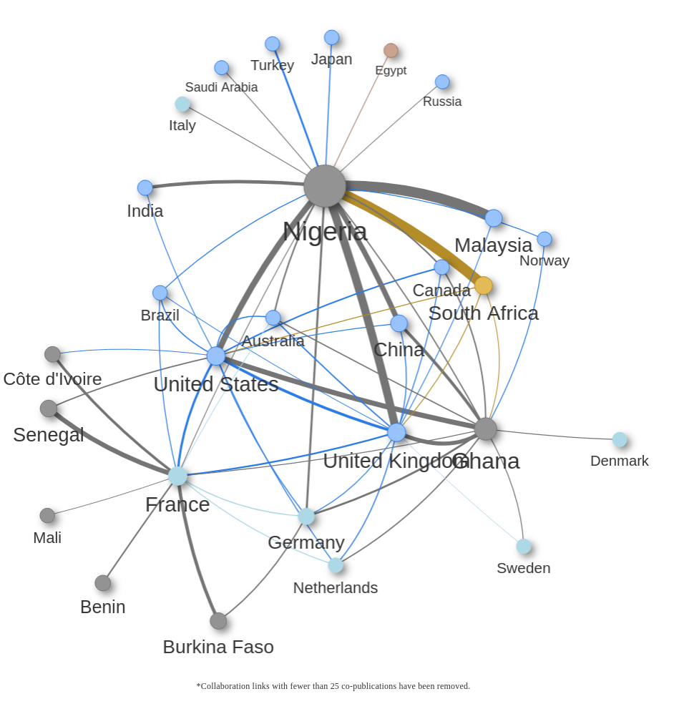Figure 18: Co-publication network of Western African countries in RE-related publications between 2011-2020

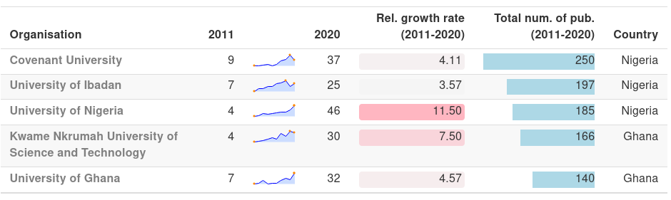Table 5: The most visible organisations from Nigeria, Ghana, Senegal cluster

All of the most visible 3 organisations in the Nigeria, Ghana, Senegal cluster are from Nigeria. The number of RE-related publications of Covenant University, the most visible organisation in the region, seems to be declining presumably because of the latency in document entries into WoS databases after 2019.

Other than Covenant University total RE-related publication outputs of other most visible organisations in Western Africa are relatively close to each other. The University of Nigeria has the highest relative growth rate of 11.5 (from 4 pub. in 2011 to 46 in 2020). Other than the University of Ibadan, the other 3 organisations were also consistently increasing numbers of their Re-related publications despite two Ghanaian organisations showing slightly more volatile progress.

**3.2.2.2 Central Africa**

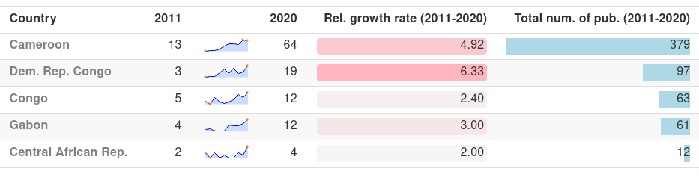Table 6: RE-related publication output in Central African countries

In the Central African region, the publication output in RE-related topics is relatively volatile. Cameroon shows a steady increment between 2011-2020 (see 3.24

1. Web of Science’s categorization of research areas under research domains can be found under <https://images.webofknowledge.com/images/help/WOS/hp_research_areas_easca.html>.
2. Relative growth rate value in this report does not indicate a percentage as it is usually calculated, instead the equation is simply end_value/start_value=growth_rate.
3. Relative growth rate value in this report does not indicate a percentage as it is usually calculated, instead the equation is simply end_value/start_value=growth_rate.